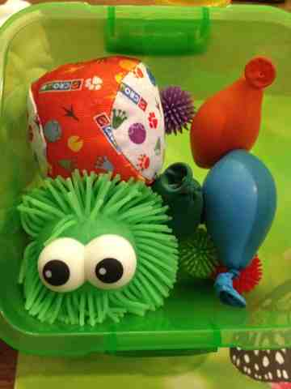
Calm Box ideas

This box can be created from an old decorated shoe box or basket containing physical objects. If it has a lid it can be more intriguing.

In the box put a small range of objects that are:
Tactile: squidgy ball (stress ball), soft toy, smooth pebble, short piece of ribbon or silky fabric or a physical puzzle like a Rubix Cube, play dough
Visual: a photo of a pet or favourite animal, funny pictures or pictures of scenes, coloured water bottle or one containing glitter, favourite picture book
Scented: a lavender bag, aroma dough
Colouring: some pencils and paper
Activity Cards: visualisation (close your eyes and go to a special place that makes you feel happy and safe), get a drink of water and drink it slowly, sorting activity, stretch like a cat
Sound: CD of favourite songs, small rain maker

